Messiah Lutheran Church—Missouri Synod

The Fourth Sunday after Trinity
July 13, 2014
Divine Service IV
Romans 8:18 “For I consider that the sufferings of this present time are not worth comparing with the glory that is to be revealed to us.” It is very easy to get caught up in the present and lose track of our ultimate destiny in the Kingdom of God. St. Paul encourages us to keep eternity in mind. This certainly has an application to our support for the Gospel – if we keep our focus on “the glory to be revealed” we will see our tithes and offerings in a new light.
Messiah Lutheran Church
Rev. James A. Roemke, Pastor
2026 22nd Ave. Kenosha, WI 53140
Church Office: 262-551-8182 Parsonage: 262-551-0944
Website: www.messiahkenosha.org
Email: secretary@messiahkenosha.org
Pastor’s Cell: 262-455-0255 Christ Lutheran Academy: 262-697-6044

VISITORS WELCOME! A special welcome to any visitors and guests who are with us today. Please introduce yourself to the pastor after the service, and we pray that the hearing and receiving of the Word of God in our midst will be filled with joy and thanksgiving!

ATTENDANCE REGISTER: During the offering we ask that you sign the attendance register located at the center aisle of each pew. Please hand the filled in sheet to the usher as you exit at the end of the service. Let the usher know if you don’t have a pad in your pew.

HOLY COMMUNION is celebrated every Sunday and on Feast Days. Visiting communicant members of the Lutheran Church—Missouri Synod are invited to commune today. All other visitors are asked to speak with the pastor before coming to the altar. If there is time before the service, introduce yourself to the pastor or an elder. Other visitors are invited to use this time for prayer. If you desire information about attending communion, you are encouraged to visit with the pastor after the service today.

PRAYERS OF PREPARATION may be found in the opening cover of the hymnals in each pew. Take some time before the service begins in quiet preparation and prayer.

+SERVING TODAY+
Preacher/Celebrant: Pr. Jack Gilbert, St. John’s LCMS, Racine
Elder: Scott Tobalsky Ushers: Tyler Nehls & Austin Nehls
Greeter: Marge Harmon Organist: Monica Scholz
Altar Guild: Kate Tobalsky & Tamara Weathersby

All Praise to Thee, for Thou, O King Divine LSB 815

+CONFESSION AND ABSOLUTION+
Stand
Invocation p203
The sign of the cross may be made by all in remembrance of their baptism.

+SERVICE OF THE WORD+
Introit Ps. 27:3– 4a, 5; antiphon: Ps. 27:1–2

The Lord is my light and my salvation; whom | shall I fear?*
The Lord is the stronghold of my life; of whom shall I | be afraid?
When evildoers assail me to eat | up my flesh,*
my adversaries and foes, it is they who stum- | ble and fall.
Though an army encamp against me, my heart | shall not fear;*
though war arise against me, yet I will be | confident.
One thing have I asked of the Lord, that will I seek | after:*
that I may dwell in the house of the Lord all the days | of my life.
For he will hide me in his shelter in the day of | trouble;*
he will conceal me under the cover of his tent; he will lift me high up- | on a rock.

Glory be to the Father and | to the Son*
and to the Holy | Spirit;
as it was in the be- | ginning,*
is now, and will be forever. | Amen.

The Lord is my light and my salvation; whom | shall I fear?*
The Lord is the stronghold of my life; of whom shall I | be afraid?
When evildoers assail me to eat | up my flesh,*
my adversaries and foes, it is they who stum- | ble and fall.

Kyrie p204
Gloria in Excelsis p204
Salutation and Collect of the Day
P | The Lord be with you.
C | And also with you.

P | Let us pray.

O Lord, grant that the course of this world may be so peaceably ordered by Your governance that Your Church may joyfully serve You in all godly quietness; through Jesus Christ, our Lord, who lives and reigns with You and the Holy Spirit, one God, now and forever.

C | Amen.
Sit
Old Testament Reading Genesis 50:15–21
¹⁵When Joseph’s brothers saw that their father was dead, they said, “It may be that Joseph will hate us and pay us back for all the evil that we did to him.” ¹⁶So they sent a message to Joseph, saying, “Your father gave this command before he died, ¹⁷‘Say to Joseph, Please forgive the transgression of your brothers and their sin, because they did evil to you.’ And now, please forgive the transgression of the servants of the God of your father.” Joseph wept when they spoke to him. ¹⁸His brothers also came and fell down before him and said, “Behold, we are your servants.” ¹⁹But Joseph said to them, “Do not fear, for am I in the place of God? ²⁰As for you, you meant evil against me, but God meant it for good, to bring it about that many people should be kept alive, as they are today. ²¹So do not fear; I will provide for you and your little ones.” Thus he comforted them and spoke kindly to them.

A | This is the Word of the Lord.
C | Thanks be to God.

Gradual Ps. 79:9–10a
Atone for our sins, for your | name’s sake!*
Why should the nations say, “Where | is their God?”
Help us, O God of our sal- | vation,*
for the glory of your name de- | liver us.

Epistle Romans 12:14–21
¹⁴Bless those who persecute you; bless and do not curse them. ¹⁵Rejoice with those who rejoice, weep with those who weep. ¹⁶Live in harmony with one another. Do not be haughty, but associate with the lowly. Never be conceited. ¹⁷Repay no one evil for evil, but give thought to do what is honorable in the sight of all. ¹⁸If possible, so far as it depends on you, live peaceably with all. ¹⁹Beloved, never avenge yourselves, but leave it to the wrath of God, for it is written, “Vengeance is mine, I will repay, says the Lord.” ²⁰To the contrary, “if your enemy is hungry, feed him; if he is thirsty, give him something to drink; for by so doing you will heap burning coals on his head.” ²¹Do not be overcome by evil, but overcome evil with good.

A | This is the Word of the Lord.
C | Thanks be to God.
Stand
Alleluia and Verse
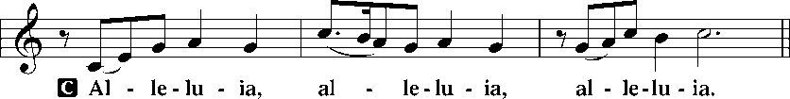
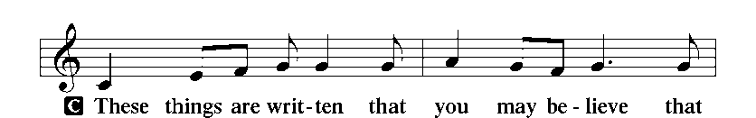
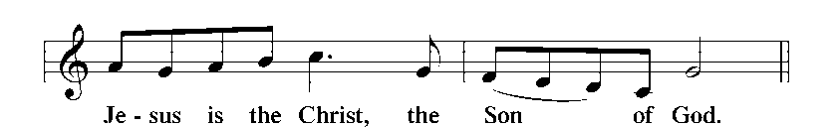
p205
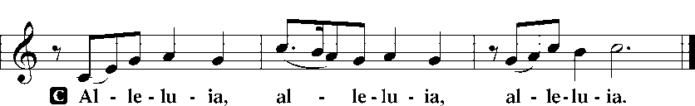

Holy Gospel Luke 6:36–42
P | The Holy Gospel according to St. Luke, the sixth chapter.
C | Glory to You, O Lord.

³⁶[Jesus said:] “Be merciful, even as your Father is merciful.
³⁷“Judge not, and you will not be judged; condemn not, and you will not be condemned; forgive, and you will be forgiven; ³⁸give, and it will be given to you. Good measure, pressed down, shaken together, running over, will be put into your lap. For with the measure you use it will be measured back to you.”
³⁹He also told them a parable: “Can a blind man lead a blind man? Will they not both fall into a pit? ⁴⁰A disciple is not above his teacher, but everyone when he is fully trained will be like his teacher. ⁴¹Why do you see the speck that is in your brother’s eye, but do not notice the log that is in your own eye? ⁴²How can you say to your brother, ‘Brother, let me take out the speck that is in your eye,’ when you yourself do not see the log that is in your own eye? You hypocrite, first take the log out of your own eye, and then you will see clearly to take out the speck that is in your brother’s eye.”

P | This is the Gospel of the Lord.
C | Praise to You, O Christ.
Nicene Creed
Sit

O God, My Faithful God LSB 696

Sermon
Stand
Prayer of the Church
Sit
Offering
Offertory Hymn- Triune God, Be Thou Our Stay LSB 505
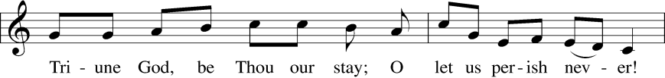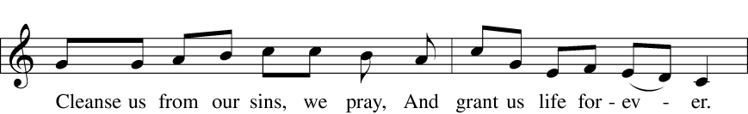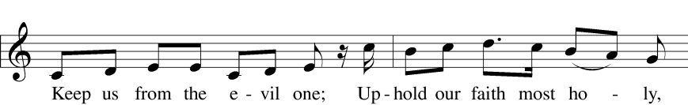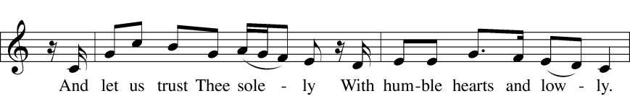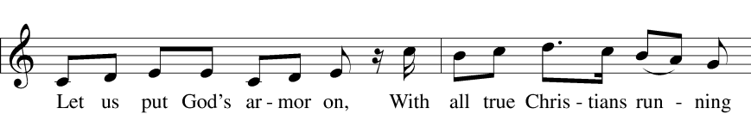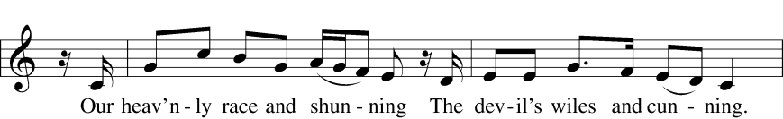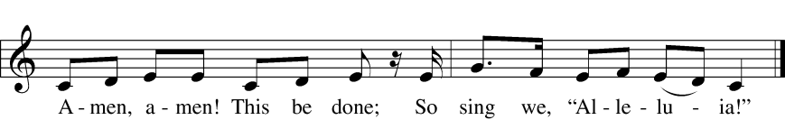
+SERVICE OF THE SACRAMENT+
Stand
p208
Sanctus
Lord's Prayer p209
The Words of Our Lord
Pax Domini
Agnus Dei p210
Sit
Distribution
I Leave All Things to God's Direction LSB 719
Lord, Whose Love Through Humble Service LSB 848
The Man Is Ever Blessed LSB 705
Stand
Nunc Dimittis p211
Post-Communion Collect p212
Benedicamus and Benediction

Almighty Father, Bless the Word LSB 923

+PRAYER LIST+
- For all the children and Christ Lutheran Academy Staff: Karen Moe, Ruth Mallmann, Stephanie Zuehls, Liesl Christensen, & Christa Hegland.
- Those who serve in our nation’s armed forces: Exor Padro, Ted & Katie Hart, and for veterans.
- Shut-ins: Elsie Rintamaki & Lillian Sciortino.
- For all those suffering from illnesses or other trials, including: Dennis Metallo, Joe Kayon, Richard Cleereman, Fred Dissen, Alison Daughtery (Metallo’s granddaughter), John Mills, Carla Krueger (cousin of Becky Noble), Diane Gundlach, Faith Peyron, Karin Zuehls (Jeff’s aunt), and Bill Dissen.

+ANNOUNCEMENTS FOR THE WEEK OF JULY 13, 2014+
QUILTS FOR SALE TODAY in narthex (approximately 60" by 80"). For $75 donation to Messiah LWML, proceeds will go for LWML quilting supplies, LWML Missions and Orphan Grain Train Charity. Pay with cash or make check payable to Messiah LWML. Pay Kathy Shafer or Kathy Capriotti. This year 21 completed quilts were sent to Orphan Grain Train for U.S. Missions. Join Messiah LWML next year to help.
LWML MITES will be collected today. A large box is located in the fellowship hall; individual boxes are also available to take home.
HELP IS NEEDED after today’s service with moving furniture in the classrooms in preparation for cleaning the floors. See Marge if you can help.
BRAT WAGON FUNDRAISER: CLA will be selling brats and baked goods at the Brat Wagon at the Piggly Wiggly on Pershing on Saturday, July 26. Sign-up sheets are in the fellowship hall to volunteer donations of supplies, baked goods, and your time for set-up, cooking and selling, and clean-up. Contact Sarah Billings with any questions.
CHURCH PICNIC: will be Sunday, August 10 after church. Sign-up sheets for food and beverages will be up soon. Please contact Allison Stephans for more info.
MEETINGS: The Parish Planning Committee and the Spiritual Life Committee will not hold their regular meetings in July. See you in August.
CONFESSIONS STUDY for July has been cancelled. It will resume on August 16.
REV. DR. MATTHEW HARRISON will be preaching at Germanfest on Sunday, July 27th at 10:30 at the BMO Harris Stage in Milwaukee. We will have a communion service here at Messiah on Saturday, July 26th for those who wish to attend. If 4:00 doesn’t work for you, please let Pastor know.
INCOME
Budgeted Lord’s Work Needed Weekly: $3,717
Lord’s Work Received 7/6: $2,118
Difference Received vs. Needed: -$1,559
Difference Received vs. Needed Year to Date: -$12,583
ATTENDANCE Sunday 7/6: 102 Communed: 77

UPCOMING EVENTS AT MESSIAH
7/26 Sat Brat Wagon CLA Fundraiser 11:00 am
Communion Service 4:00 pm
8/8 Fri Songs For A Summer Night CLA Fundraiser TBD
8/10 Sun Church Picnic 11:00 am

BIRTHDAYS BAPTISM BIRTHDAYS
7/13 Krista Bruneau 7/13 Ethan Tobalsky
Ashley Noble 7/14 Keith Kentala
Anna Walther 7/15 Cora Szela
7/14 Meri Jo Cleereman 7/17 Diane Kentala
Jamie Kauppila 7/18 Cheryl Moe
7/15 Troy Kulbacki Valerie Zuehls
7/16 Bradley Brothers 7/19 LeAnn Varvil
Mitchel Kauppila
7/18 Shane Pederson

